ScoreSense: Goal Line Detection in Soccer using Radio-Frequency IDentification

Teddy Ariel, Kendall McCullom, and Mira Yun

Department of Computer Science

Boston College

Chestnut Hill, MA 02467, USA

{ariele, mccullkg, yunmd}@bc.edu

***Abstract*—Current technology in the sports world can lead to lengthy delays when it comes to reviewing controversial plays. The time taking to review these plays lead to viewer disengagement, player dissatisfaction, and disrespect and aggression towards officials who are left to make these decisions. Traditional solutions, such as using magnetic fields, cinematic features, or image processing, are often too expensive to implement in tens to hundreds of stadiums in specific leagues, and oftentimes still either take too long, or do not always provide accurate results, leaving the fans frustrated, just as before. The paper introduces a cost effective method to easily determine if a goal has been scored in soccer utilizing Radio Frequency Identification (RFID) tags and a RDM6300 RFID Reader to simulate the ball and a goal on a table top device. By using these tools along with an Arduino Uno microcontroller board, jumper wires, and LEDs, we can create an Arduino interface that detects when the RFID tags have passed through the scanner. By altering our system to account for all possible situations in a real game of soccer, our system effectively and quickly determines whether or not a goal has been scored by detecting every RFID tag. Along with being cost effective, evaluation shows that our system would be ideal in shorting review time in goal scores in soccer, thus increasing overall enjoyment of the game.**

***Keywords—* Radio Frequency Identification, Goal Line Detection, Feedback Signals, Soccer, Arduino, Integrated Circuit Modeling, Sports**

# **I. Introduction**

Why should we care about wireless technology in sports? Playing and watching sports has a significant impact on a large part of the population. 70% of Americans have reported that they are fans of professional or college sports, and 53.8% of adolescents participate in sports. This clearly demonstrates how crucial sports are for the average American in the current era.

Sports are also proven to have a positive impact on a person's life. It has been reported that 65.6% of people were happy when their team was successful in a major event, and for those who actively participate in sports, their life satisfaction was 0.4 points higher than those who did not. This comes due to the participation in sports resulting in better physical and mental health for active players. From this, we can see the clear positive impact that sports leaves on citizens, whether it be as a participant or as a viewer.

Also, sports provide major economic benefits for areas on both a local and global scale. The sports industry is a $500 billion dollar industry. With that it is crucial in providing jobs, attracting tourists, and holding events in cities. All of this helps gain economic traction in local economies, allowing for city growth and expansion. In 2021 alone, professional and collegiate sports created 635,000 jobs and produced $91.8 billion dollars total economic impact in Texas. In a similar fashion, in 2023, sports-related travel had a $128 billion dollar economic impact. Based on these numbers, it becomes evident just how crucial sports are for the global economy[1].

Sports around the world continue to evolve as new technology is produced, developed and implemented in a variety of sports. Sensors are one of the most recent technological developments in the sports world that is revolutionizing the way we collect data. Wireless sensors are being placed inside of sports equipment and attached to players themselves to further enhance data collection in a multitude of ways. These wireless sensors are helpful in gathering more accurate statistics, helping improve the performance of athletes, and prevent injuries. Also, these sensors improve the overall experience for viewers through providing live statistics during broadcasts. Many national sports leagues have introduced this technology, including the National Basketball Association, Major League Baseball, the National Hockey League, the National Football League, and professional soccer leagues. Beyond the world of professional sports, COVID-19 and the desire for affordable and accessible training widely grew the wireless sensor technology for amateur athletes. During a time where it was necessary to remain out of gyms and away from coaches, wireless sensors gave athletes a way to gather data and statistics by themselves.

There are two main aspects of wireless technology in sports: those that involve the players and those that involve the equipment. Wireless sensors in regards to the players consist of devices that can be worn on the body or embedded into their jerseys. These sensors can track the players movements, biological indicators, (heart rate, body temperature, muscle activation, etc) and position on the playing field. Wireless sensors in regards to the equipment consists of devices that are embedded within different pieces of equipment. This can vary from the projectile to the hitting tool, to the field of play itself. This technology is very new and is currently entering the market.

These sensors are beneficial to both athletes and coaches. With these sensors, athletes are provided with tangible data which can be used to track statistics, set goals, and know what needs to be improved upon. Furthermore, these statistics enhance the viewing experience for fans, as these statistics are provided to announcers and broadcasted on screen. This helps viewers learn the game and better understand what is going on.

As a result of having more data available, the sports industry will be able to continue its rapid growth. More people will be attracted to the game as it will become more accessible and understandable. Also, games will become more entertaining as player performance will improve as a result of more precise training metrics.

One sport that has truly embraced this growing technology on a global scale is soccer. Wireless sensors have been added to players' jerseys and within the ball itself in order to gather data about games and players. One crucial element to consider when adding sensors to equipment is that it can not alter the way the game is played. This means that the players should not be able to tell that sensors are located in the ball, as that would result in them playing differently.

Goal line detection is an issue within the game of soccer that has been widely debated for years. Along with all of the other benefits that wireless sensors provide, this paper will focus on how sensors embedded in the soccer ball can help with the issue of goal line detection.

# **II. The Problem**

Wireless sensors have the potential to ease the issue that is verifying goals, otherwise known as goal line detection. The current technology used in professional soccer leagues to determine whether or not a goal occurred is reliance on the referees. If the referees can not make a decision in the moment, they then must utilize video review technology to check if the goal is legitimate. A legitimate goal occurs when the ball completely crosses the goal line, between the posts and below the crossbar (Figure 1). The referees must use video review to determine whether or not the shot meets that criteria. Throughout the years, there have been several incidents at big stages of World Football that were highly controversial and led to many debates as a result of the referees not clearly being able to determine whether or not a goal occurred. This continuous disagreement led to the solution of goal line technology.

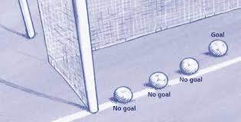

1. Example of the goal line rules in soccer [2].

One key example of these goals include England’s Frank Lampard’s shot in the 2010 World Cup. In this game, Lampard’s shot bounced off of the crossbar and over the line, but the referee called off the goal. Following this call, England went on to lose to Germany in this game, sparking controversy in regards to that call by the referee. This caused the FIFA president to open the discussion of goal line technology and issue an official apology to the English Soccer team [3].

With the current system, soccer has long review periods on hard to call goals. This delay of game time can disrupt the flow of the game for players and lead to fan disengagement. This also leads to inaccurate calls that sway the outcomes of the game. In the modern era, technology is much faster and more advanced than the human eye, so there is no reason to be reliant on humans to make these calls when we can implement technology to always make the correct call. In this experiment, we plan to create a system that utilizes sensors to detect goals accurately in real time.

We are going to specifically look at wireless sensors and goal line detection. Goal line detection is the technology by which we can determine whether a goal has been scored or not. Current solutions all use cameras, expensive electronic equipment, magnetic fields, or complex algorithms. We are proposing a cheaper system utilizing an Arduino Radio Frequency Identification (RFID) interface, which will be faster, more efficient, and more accurate than previous systems. This will dramatically increase the speed of reviewing goals, as it will provide almost instantaneous feedback, eliminating the need for lengthy replays.

# **III. Current Solutions**

There are many current implementations that try to solve this problem as well, each with their own shortcomings.

The first being Spagnolo et al.’s solution. Spagnolo proposed a solution where candidate ball regions are analyzed to detect the ball. This involves having three cameras recording each goal: two parallel to the goal frame and one perpendicular. All of these processors are then connected to a main node. This main node has a decision making function based on the processing results coming from the cameras. Using the time space coherence of the ball's 3D trajectory, the main node can determine if a goal has been scored.

While this solution does help with the goal line detection issue, it also introduces a world of issues. The cameras used in this technology are very sensitive. This means if there are other objects in the area, such as players, towels, or water bottles, the main node may think a goal has been scored. Also, if a specific color scheme on a jersey is sensed, this may also cause a faulty goal to be called [4].

Another solution was proposed by Ekin et al, which uses cinematic features to determine whether or not a goal has been scored. This solution uses color region detection, shot classification, and shot boundary detection to determine whether or not a goal has been scored. These features are used together, as they take into account the fact that specific features, colors, and atmospheres may change depending on which stadium the game is taking place in [5].

This solution oftentimes still relies heavily on the referees to determine whether or not a goal was scored. The system proposed is more of a back up to double check the call from the referee. While functional, we are hoping to develop technology that is independent of the referee and can determine whether a goal was scored solely based on the location of the ball.

There are many other strategies implemented in order to solve this problem as well, some including the use of a radio-based system, magnetic fields, and processing tools [6].

A common theme amongst all these solutions is the price. The cost of implementing some of these technologies can reach up to $4.3 million per season. This includes the $260,000 installation fee, plus the cost of maintaining the system throughout the season. This has caused several leagues, including La Liga, to argue and avoid installing these systems. The argument reigns that it is an unnecessary cost given the other technology already implemented in every stadium (including many camera angles). Others argue that they do not believe that the technology is accurate enough, citing several goals that they believe were called incorrectly by the current goal line technology [7].

# **IV. Our Solution**

This paper introduces a solution that relies on the use of radio waves to identify whether or not the ball has passed into the net. By using Radio Frequency Identification (RFID), we can use sensors to determine if the qualification for a goal has been achieved.

RFID tags are a technology that we use everyday in things like credit cards, proximity cards, and EZ passes. A sensor can detect these tags using radio waves and can provide the specific information that is held within this tag. This can be used to identify people, objects, or in our case, a soccer ball. This technology is useful in our case due to the fact that this information can be read at a distance and without the need for physical contact. Essentially, these tags act as a “smart label” that can be attached to various items, and when it is scanned by the reader, the tag reveals the unique information that it holds. The reader emits radio waves of a specific frequency which activate the tag’s antenna, allowing the tag to transmit its stored data back to the reader [8]. In this experiment, we are utilizing RFID with an Arduino interface.

The required materials for our RFID system include an Arduino Uno microcontroller board, a RDM6300 RFID Reader of 125 kHz, several RFID passive tags of 125 kHz, a breadboard, jumper wires, and LEDs. The circuit model is shown in Figure 2.

In the RFID tag, information is stored in the form of binary bits. When the reader detects an RFID tag, it sends out a message of a data frame that is 14 bytes through serial connection. The first byte of the frame is the head, bytes 2-11 are the data, bytes 12-13 are the Checksum, and the final byte is the tail. The value of the head is always *2* and the value of the tail is always *3*. The data itself contains the actual tag information in hexadecimal values that must be converted into ASCII values. Once the checksum value of the tag is calculated, it is compared to the checksum value of the transmitter, then the process proceeds.

In our system, we found it unrealistic to implement our model on an actual soccer field. In order to test our system, we used a ruler to simulate the soccer ball and the wire loop antenna of the RDM6300 to simulate the goal. We attached four RFID tags to the ruler (Figure 3) and dragged the ruler through the antenna (Figure 4) to simulate scoring a goal. The RDM6300 is provided with power through the Arduino, and its antenna continuously emits a 125 kHz radio frequency signal.

In our model, if all four of the individual RFID tags cross and are detected, they send a feedback signal to the reader via the RFID coil. Upon receiving this signal, the reader delivers a signal to the LEDs on the breadboard, simulating that a “goal” has been scored, otherwise this would not be a goal. Since the LEDs light up immediately once the RFID tag is sensed, the detection process is instantaneous. This setup aims to simulate if we placed RFID tags on several points of a soccer ball, and placed the wire frame along the back of the goal line, the posts, and the crossbar. If the wireframe detected all of the tags on the ball, then that would mean the ball completely crossed the goal line, and is thus a valid goal. The LEDs would thus signify to the referees the outcome of the shot (goal or no goal), and the game would promptly continue according to the call.

As each tag crossed the RFID coil, the serial number of the tag was recorded, and an LED light corresponding to that serial number would turn on.

The LEDs are a clear indicator as to whether or not a goal has been scored, meaning that there will be almost no reason to have a review period within the game. If there was a need for a review period, the officials could simply review the log to see which RFID tags were scanned. They can quickly check to ensure all of the RFID tag serial numbers are present, and if they are, that means it was a valid goal.

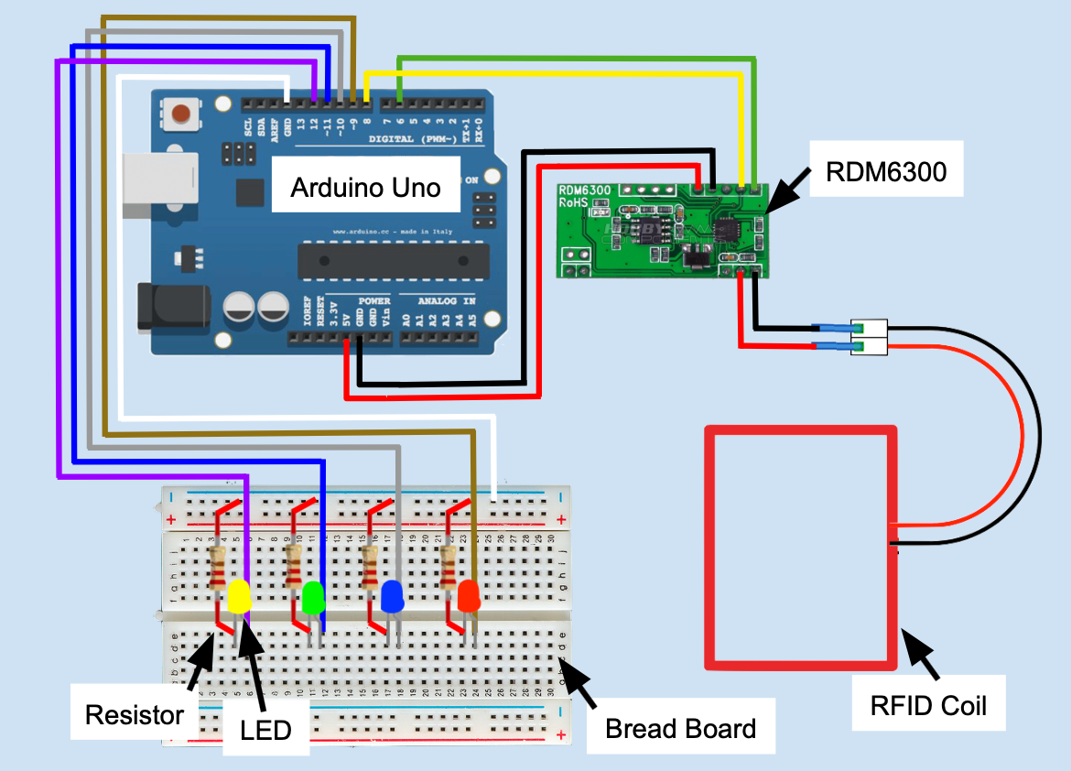

1. Circuit that shows how jumper cables should be connected from the Arduino Uno to the RDM6300 module and the bread board.

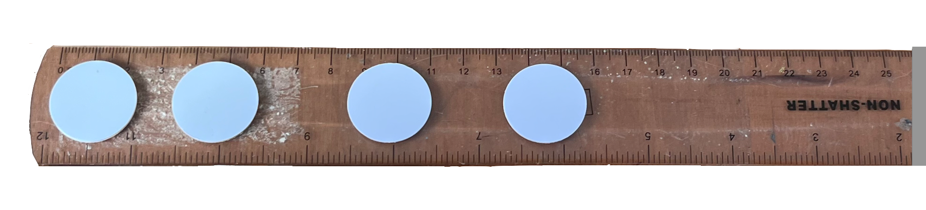

1. Configuration of RFID tags on the ruler.

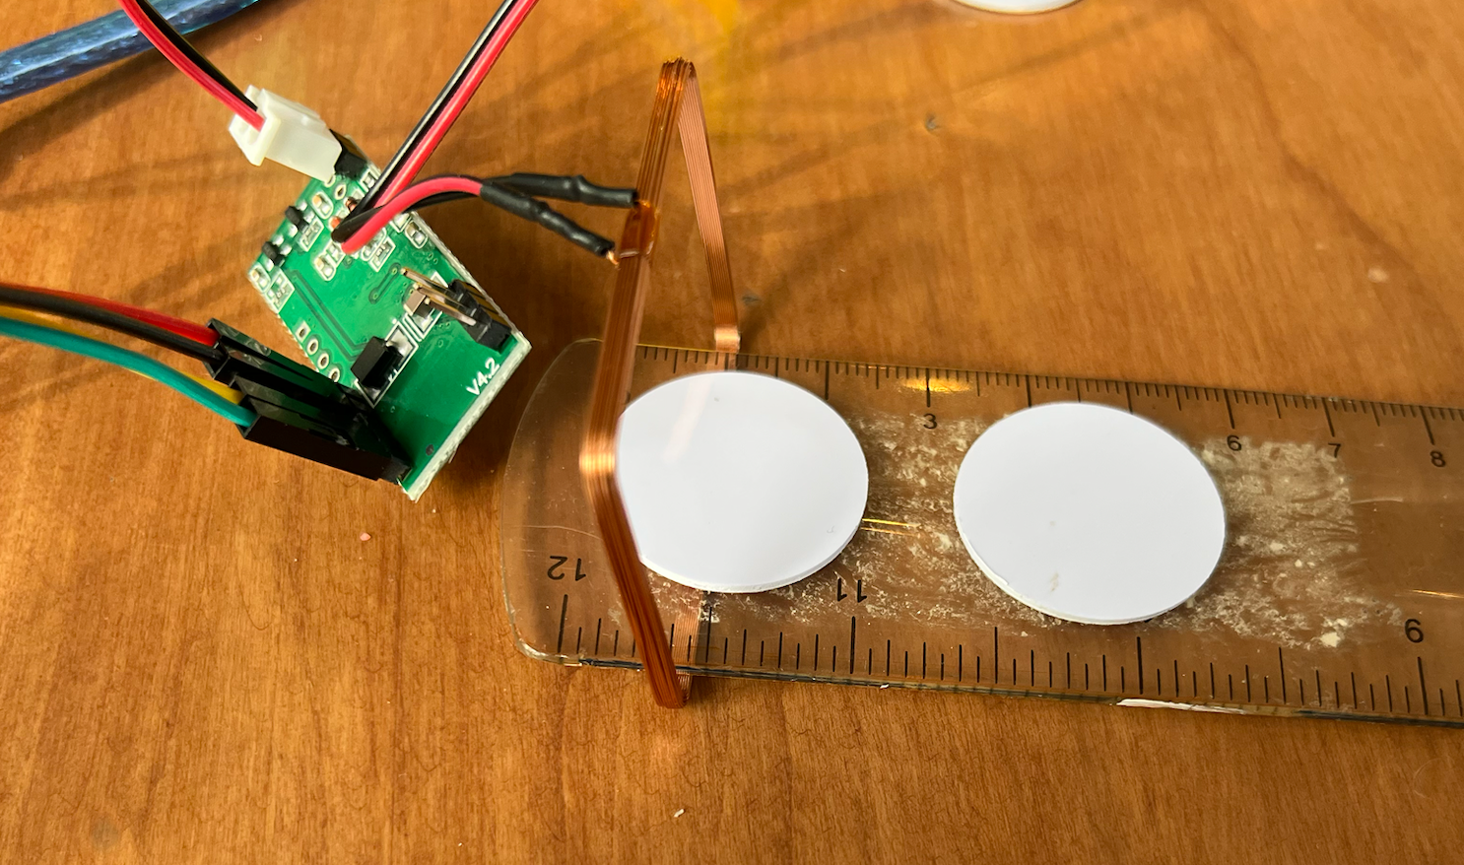

1. Mechanism of how the experiment was tested by moving the tags on the ruler through the wire coil.

# **IV. Pseudo Code**

This is the Pseudo code of the code that was used in Arduino IDE to run the experiment. The Arduino Uno was connected to the laptop (acting as the power source) via a USB cable which is compatible with Arduino.

#include <SoftwareSerial.h>

DEFINE byte sizes of RFID tag information

DEFINE the serial tags numbers of each tag

DEFINE Arduino pins of jumper wire connected to LED

DEFINE Arduino pins connecting to RDM6300’s TX pin and RX pin using SoftwareSerial();

DEFINE Byte Buffer to store incoming data frames

DEFINE a Buffer index = 0

void setup(){

Serial.begin(9600);

Serial.println("Setup Complete");

BEGIN listening;

CONFIGURE pins to behave as an output using pinMode()

SET all LEDs go off

}

void loop(){

if (# of bytes available from software serial port > 0){

bool extractTag= false;

READ character received from RX port

if (no data read){

return;

}

if (tag found){

reset index;

}

else if (tag transmitted){

extractTag = true;

}

CHECK for a buffer overflow

COPY current value to buffer

if (extractTag == true) {

if(TAG1/TAG2/TAG3/TAG4 crosses RFID coil){

Serial.println(Serial tag);

LIGHT-UP corresponding LED using digitalWrite();

}

if (ALL TAGS recorded) {

Serial.println(“VALID GOAL!”);

}

}

else {

SET index to 0;

return;

}

}

# **IV. Results**

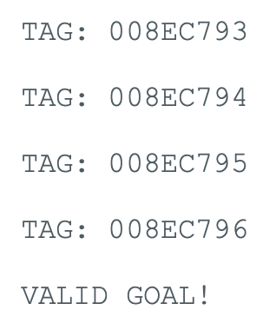

1. Valid goal example output when each tag is scanned once (if ruler goes through straight).

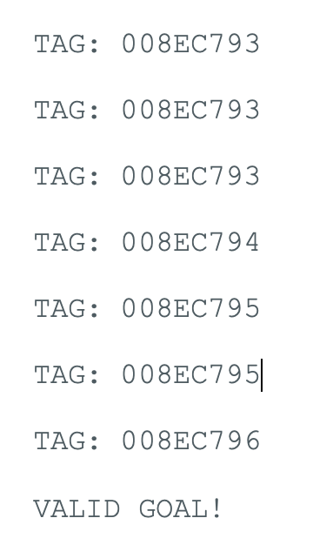

1. Valid goal example output when some tags scanned multiple times (if ruler when ruler moving through coil pauses on some of the tags).

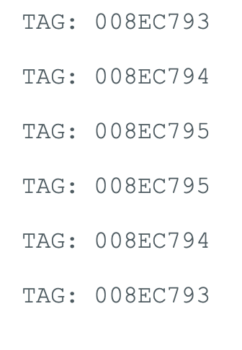

1. Invalid goal example (if ruler pushed halfway through, and then pulled back out without the last tag being detected by the coil).

# **V. Evaluation**

The first aspect of our system that is worth evaluating is the cost. The use of the passive RFID tags make the system significantly cheaper than previous models. The overall price for this setup was less than $40: an Arduino Uno is less than $8, a RDM6300 is less than $8, several RFID passive tags are less than $10, and a breadboard kit that includes jumper wires, LEDs, and resistors is less than $10.

Clearly, our system is not applicable to large scale soccer stadiums in its current form. As we scale up our model, the price will increase with it. Still, the final price point will still be significantly less than $260,000 per stadium. Also, as you can see, our model is relatively simple. There are not many moving parts that constantly need to be upheld, meaning maintenance costs for this model would be less as well.

Another aspect of our system that is worth mentioning is the RFID reader coil. This antenna is simply made of wire. This means that the shape and size of the coil is malleable, making it easy to adjust depending on what you are attempting to measure. In our case, this makes it easy to scale our system up in size, and have the coil take the shape of the soccer goal.

One of the many benefits of using RFID tags is that each tag has a unique, identifying serial number. Using this information, as a tag crosses the wire frame, we can identify which tag it is. With this, we can ensure that each tag on the soccer ball crosses the goal line, meaning that a valid goal has occurred. In our example, we want to ensure that each of the four RFID tags on the ruler passed through the wire frame. As we can see in Figure 5, we have four unique hexadecimal codes, representing the four different RFID tags, which is why we get the “valid goal!” message.

In our original testing, we did not differentiate between our separate tags, instead depending on counting the number of times a sensor crossed the wire RFID coil. The RDM6300 can transmit the same tag multiple times, so if the tag is held to the coil for an extended amount of time, then the RDM6300 will record the data multiple times. There are two potential problems here. Firstly, in some close call goals, the ball can cross halfway, and then be pulled back across the line, thus detecting some of the same sensors twice, which would give us a valid goal on a goal that should not have counted and turning all of the LEDs on prematurely. Secondly, if one of the sensors on the ball sits on the goal line for extended amounts of time, it will be recorded several times, so this again would prematurely call a valid goal.

In order to adjust, we decided to identify each tag individually. As each tag crossed the RFID coil, the corresponding LED would turn on, and a valid goal would only be recorded once all of the tags passed and all of the LEDs had turned on. This process required us to use an RFID reader to scan the tag and get the serial number of each tag before running the program so that we knew which tags must be identified.

In Figure 6, we can see a simulation as if the soccer ball was resting on the goal line as it is passing through. In the figure, we can see that there are seven tag scans, but some of them are repeated. This means that the ruler paused as it was being pulled through. Our system is programmed to not search for four tag scans, rather four unique tag scans. We can see that after the seventh scan, which is the fourth unique tag, we get the “valid goal!” message.

In Figure 7, we can see a simulation as if the soccer ball partially crossed the goal line, but was pulled back. In the figure, we can see that there are six tag scans, with some of them being repeated. This means that in our model, the ruler was pushed partially through, and then pulled back out of the RFID reader loop. Once again, our system is programmed to find four unique tags. In this example, instead of getting a fourth unique tag, it only gets repeated, which is why it does not deliver the “valid goal!” message.

The entire process of scanning the RFID tags, determining when it has four unique tags, lighting up the LEDs, and displaying the “valid goal!” message only takes a total of 3-4 seconds. This is crucial for our model, as the purpose is to limit the number of long delays in game play. With the short time it takes to determine whether or not a goal was scored, it will not interfere with the fast pace of the game.

# **VI. Conclusion**

In this experiment, we developed and evaluated an affordable RFID based system to help mitigate error when it comes to goal line detection in soccer matches. This system will help speed up the game, helping retain viewer attention and keep players engaged within the match, while also providing accurate results, creating a healthier relationship between fans, teams, and match officials.

We were able to model a soccer match using a table top system, with a wire loop antenna of the RDM6300, along with a ruler containing multiple RFID tags. This cheap table top setup is meant to represent a soccer goal, and can easily be scaled up to do so.

The ruler with RFID tags is symbolic of a soccer ball. This method of demonstration made sense for our model, as our “goal” was small, so having something narrow to drag through the RDM6300 was the natural choice. When scaling to a soccer ball, the number and orientation of RFID tags can be altered in order to optimize the accuracy of the system.

In our experimentation, we can clearly see that our system provides an accurate way of detecting whether or not a goal has been scored in soccer. By having each RFID tag connected to an LED, it becomes very clear whether or not the criteria of a goal has been met, and it also becomes clear to the crowd too, as these LEDs will be visible to everyone in the arena. Furthermore, even if there was a disagreement between teams and the officials on whether or not a goal has been scored, printing out when each RFID tag has been scanned makes for a quick, easy, and concise explanation behind each call. The officials can quickly show the coaches which tags have been scanned and which have not, and use that as justification behind every call.

By acknowledging the possibility of having a tag or multiple tags scanned multiple times, we were able to make alterations to our system which allows that to happen without accidentally signaling a goal. This was an important change, as this is something that is bound to happen within soccer matches, so we must alter our system to account for any possible account in any given game.

While this system is extremely effective when it comes to detecting a goal in soccer, it can also be expanded to detect other features in soccer. For example, with a few alterations this system can be used to detect whether or not a ball has been kicked out of bounds or if it has stayed in bounds.

Furthermore, this system can be expanded to broaden its scope. By studying the rules of different sports that require line detection, such as football, lacrosse, basketball, and more, we can alter the system to abide by these line rules, and we can then apply our goal line detection system to that specific sport. This challenge that comes with this future implementation is the vast amount of different rules in these different sports. For example, a touchdown in football is scored when any part of the ball crosses the goal line, not necessarily the whole thing. This differs from soccer, which requires the entire ball to cross in order to score a goal. This would require a change in the “valid goal” criteria in our implementation, but aside from that, the system has the ability to be scaled up to detect a goal in a variety of sports.

Another future implementation would be shifting the focus away from balls in sports, and focusing on human movement. In almost every sport there is a boundary which separates in bounds and out of bounds, with a change of possession occurring when the ball or player goes out of bounds. We previously stated that a simple change in the goal detection software can be made to detect when a ball exits the field of play, but a more complicated change would be needed to detect whether a player themselves is in or out of bounds.

This software would be equally, if not more important for speeding up play in sports, when it comes to human out of boundary detection. In sports such as football, basketball, and baseball, there are often lengthy review periods as to whether or not a player was on the line, touching a base, or in the field of play. In order for our software to detect these kinds of behaviors, RFID tags would need to be placed on the human in whatever part of the body we are tracking (most likely in a cleat to detect a foot). With this, we can use our technology in a reverse manner. If the field of play was represented by the RDM6300 antenna, we would want to check when the RFID tags are no longer being scanned, meaning they have exited the perimeter of the field, thus marking them out of bounds. This future implementation would require more technology and cooperation with leagues in order to get RFID tags implemented in all sorts of equipment, but it would still be a cheap option to speed up the rate of play.

##### **References**

1. Esther Lee Rosen, E. L. Y., Holzer, H. J., & Watson, T. (2016, July 28). *Sports, jobs, & taxes: Are new stadiums worth the cost?*. Brookings. https://www.brookings.edu/articles/sports-jobs-taxes-are-new-stadiums-worth-the-cost/
2. *Publications/Laws*. U.S. Futsal. (n.d.). https://www.futsal.org/publications/laws/
3. McHaney, S. (2014, June 16). *Goal-line technology begins to clear controversial goals*. PBS. https://www.pbs.org/newshour/world/goalline-technology-begins-clear-controversial-goals
4. Spagnolo, P., Leo, M., Mazzeo, M., Nitti, N., Stella, E., & Distante, A. (2013). *Non-invasive Soccer Goal Line Technology: A Real Case Study*. IEEE Conference on Computer Vision and Pattern Recognition Workshops. 10.1109/CVPRW.2013.147.
5. Ekin, A., Tekalp, A. M., & Mehrotra, R. (July, 2003). *Automatic soccer video analysis and summarization*. IEEE Transactions on Image Processing. 12(7), 796-807. 10.1109/TIP.2003.812758.
6. Ghosh, S. et al., (2019). *Radio Frequency Identification Based Goal Line Technology for Quick Decision Making in a Football Match*. Devices for Integrated Circuit (DevIC). 441-445. 10.1109/DEVIC.2019.8783918
7. Leveridge, S. (2024, May 2). *Why La Liga doesn’t have goal-line technology*. Forbes. https://www.forbes.com/sites/samleveridge/2024/04/22/why-doesnt-la-liga-have-goal-line-technology/#
8. *Radio Frequency Identification (RFID): What is it?: Homeland security*. U.S. Department of Homeland Security. (n.d.). https://www.dhs.gov/archive/radio-frequency-identification-rfid-what-it#:~:text=Radio%20Frequency%20Identification%20(RFID)%20technology,requiring%20a%20line%20of%20sight